An interesting artist
By Alex Meisler

David Channon is an artist and sculptor who is currently hosting a show called “It’s them or us, and we are them.” These are mostly paintings of invasive species of bugs with highways, and/or drilling plants in the background that cause pollution and damage the earth. He also had many sculptures of birds and a mermaid made out of scrap metal, old tools, doorknobs and other found objects.
Dave says that he is a multimedia artist with a bit of science fantasy mixed in. When I saw his art show it had exactly that.
Dave has been an artist for a long time, whether doodling in his notebook during school or welding metal together right now. He says that “I was always one of the best artists in my grade.”
Mr. Channon told me that his aunt liked to paint things you would see hanging in a pizza parlor and his mom was a writer and liked to doodle.
His mom was a very big inspiration to him becoming an artist. His mom was always encouraging when he was making art and always thought it was nice when he made stories or little doodles. And later on he found out the only thing he could really do, as a successful career, was to make artwork. The only other career Dave ever wanted to do was to be a meteorologist (but we’re lucky he became an artist).
Dave has done lots of artwork so it was very hard to choose one that he liked the most. When I asked that question he said “Well that’s just not fair”. But in the end he said that a metal mermaid sculpture he made was probably the one he like the most.

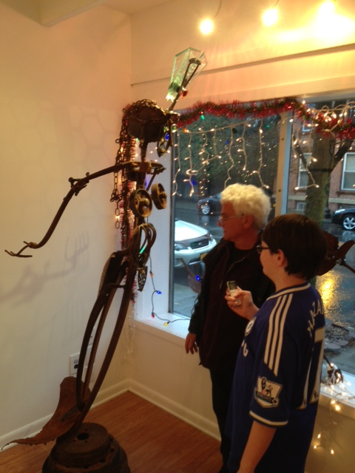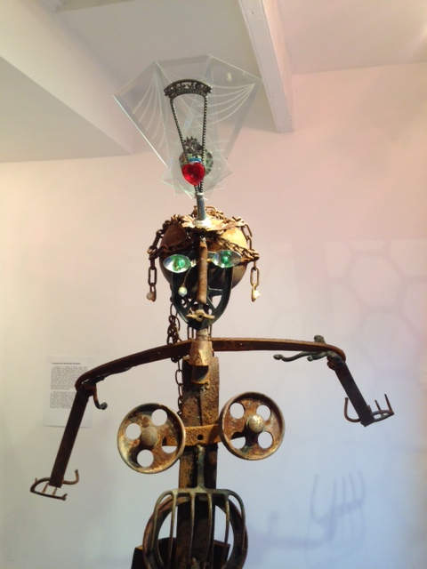

When I asked Dave if art came easy to him he said that “sometimes it flows but a lot of times it is difficult to process and feel the satisfaction.”
Dave also thinks that asking him what his favorite piece of artwork not owned by him is an unfair question, but if he had to pick one he’d pick the “David” by MichealAngelo.
I asked Dave if he admired any other artists. He said that he admired art from the movie “The Hobbit” and a local artist named Tim Slowinski and another local artist named Steve Heller.
Dave started making sculptures when he was doing a river cleanup with his neighbors. There was a lot of metal in river. He started thinking about what he could make them into and asked his neighbor for her welder. He has since collected a lot of metal!

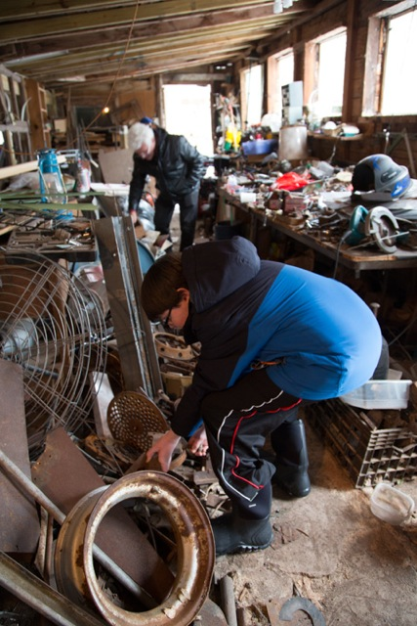

It’s always nice when you finish any artwork. Dave says “it gives me satisfaction and makes me feel like I’ve done something to make my existence on earth more worthwhile.” He also doesn’t know if it is finished but he is just too anxious to go to the next painting and will sometimes see it again and think he could have done more.
He also says that drawing women is very inspiring. Dave also likes to draw any living creature or landscape and then add stories to them.

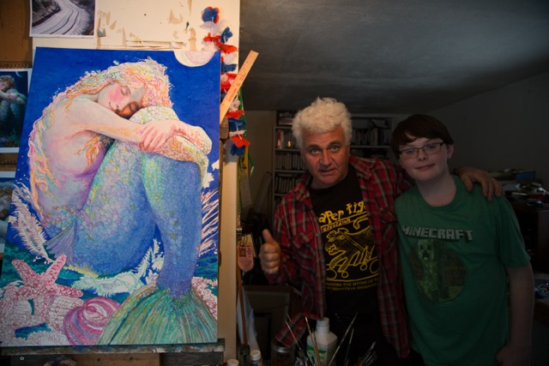

In conclusion, I enjoyed spending time with Dave at his studio and getting a tour of his home (a 100 year old farmhouse). He is a cool person that cares about the environment and I like his work. It was exciting to make my own sculpture and visit the Limner Gallery!
Dave Channon is an interesting artist.

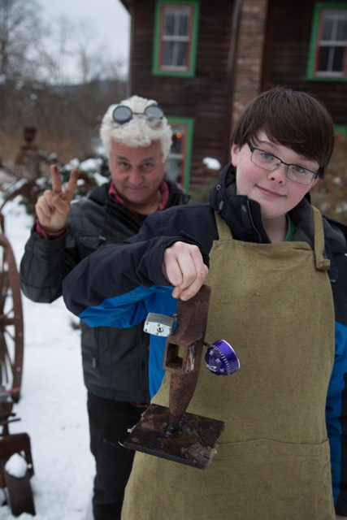

Dave Channon is a multimedia artist at www.esopuscreek.com.
Dave has thick grey hair and he’s not very tall. He wore jeans with a leather jacket. He makes paintings in his house and his sculptures in an old chicken pen. I was lucky enough to see his art show in Hudson, New York and go to his studio where he helped me make my own sculpture!
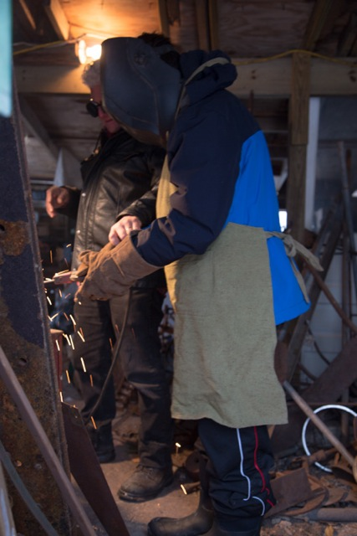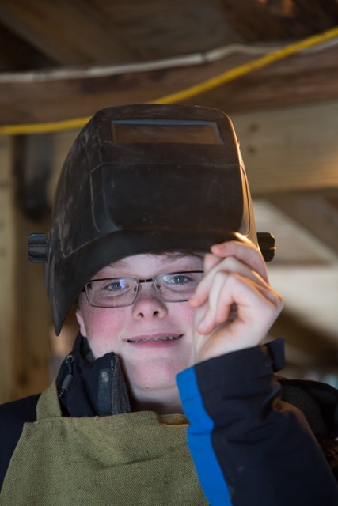
One of his paintings is called “Mrs. Ladybug.” It is an invasive Japanese ladybug on a leaf over a highway laying eggs. The highway is in the background with dull muted colors and the ladybug is upfront with very bright bold colors. I like his work…it makes me feel aware.

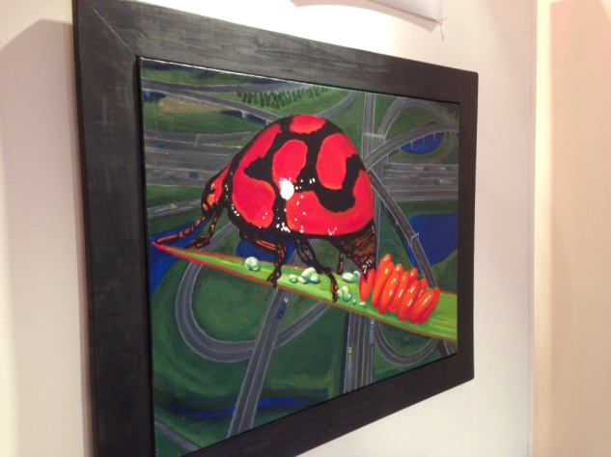

Interviewing Dave Channon at the Limner Gallery
